Employment Transition Services: A Partnership Between Career Services, Human Resources, and the Employee Assistance Program

Devan Coughlin, B.B.A.

Florida State University, Tallahassee, FL

Roundtable presented at the annual meeting of
the National Career Development Association, San Francisco, CA

Table of Contents

Employment Transitional Services Overview 2

Services by Partner 3

Career Center Specific Services and Processes 4

Planning, Collaboration and Recruitment...................................................................5

Evaluation.......................................................................................................................5

Employment Transition Group/Professional Job Club Overview 5

Screening 6

Evaluation Plan 6
APPENDIX A: Recruiting: Department Chair Letter…………………………….....8

APPENDIX B: Recruiting: Employment Transition Group Referral Handout….9

APPENDIX C: Recruiting: Professional Job Club Card………………………….10

APPENDIX D: Screening: Data sheet………………………………………………11

APPENDIX E: Professional Job Club Agendas 1-5……………………………...13

APPENDIX F: Professional Job Club Worksheets 1-5…………………………...19

*All Professional Job Club materials were prepared in collaboration with Susie Musch, Career Advisor, Florida State University Career Center

*Employment Transitional Services information prepared with special contributions from Dr. Jeff Garis, Director, Florida State University Career Center
Program Overview
KEYWORDS [Individual Learning Plan (ILP): identifies a sequence of resources and activities to help the client attain his or her goals for career problem solving and decision-making” (Sampson et al, 2004, p. 58).

Impacted: describes employees or departments that have been affected to some extent by the budget crisis.

Career Thoughts Inventory (CTI): a 48-item used to assess dysfunctional thinking (Sampson, Peterson, Lenz, Reardon, & Saunders, 1996).

Readiness: “the capability of an individual to make appropriate career choices while taking into account the complexity of family, social, economic, and organizational factors that influence an individual’s career development” (Sampson et al., 2004, p.68).]
Employment Transitional Services (ETS) is a dynamic, collaborative program created in response to the Florida State University (FSU) budget crisis in 2008 for the purpose of serving employees who have been laid off, have a spouse who has been laid off, or are concerned about current economic uncertainties. Human Resources, the Career Center, and the Employee Assistance Program have a dedicated team with an array of resources available to help employees impacted by the budget crisis.

Impacted Employees
At the beginning of 2009, it was estimated that approximately 200 university employees would be impacted by the budget crisis, including faculty, A & P and USPS staff. Over the course of the year, stimulus funds became available and prolonged job loss, however intermittent individual notices and departmental cutbacks complicated the preparation process for employees as a whole. As a result, the Career Center has been proactive in establishing the framework for serving this population despite infrequence of use and undesired continuity of service.

Partners and Primary Roles

Figure 1: Partners and Primary Roles
The Career Center
Outplacement: to identify career goals including job searching and career choice

Human Resources
Inplacement: to identify alternative job opportunities at FSU

Employee Assistance Program
Emotional Support: to identify triggers and assist with mental health adjustment

Services by Partner

Figure 2: ETS Website Homepage

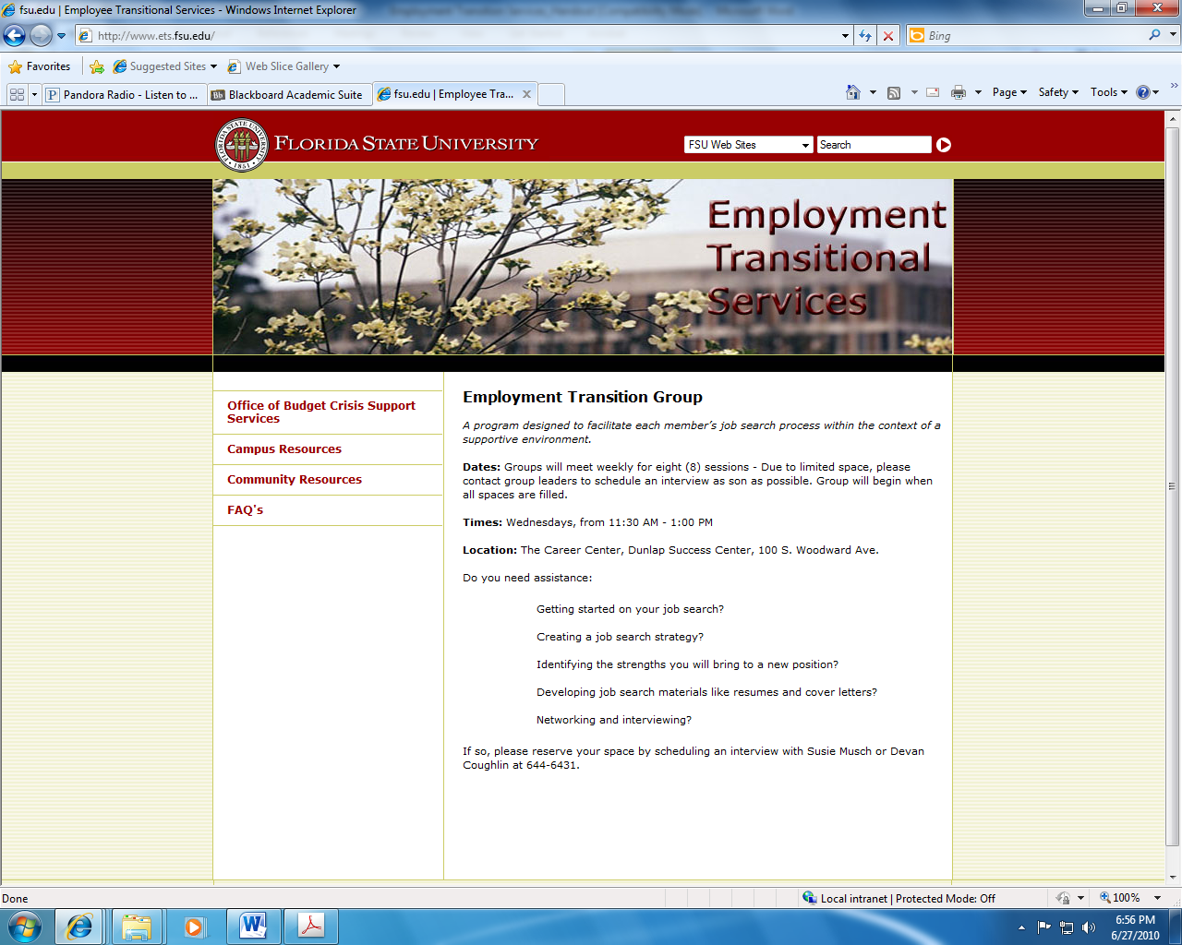

Florida State University Career Center
- Screening
- Drop-in Advising for a specific concern
- 30 minute orientation/plan for using Career Center services
- 60 minute counseling slots for follow-up sessions
- Professional Job Club

Employee Assistance Program
- Counseling for emotional support, financial strategies, stress-relief
- Emergency Loan Fund
- Professional Job Club referral source

Human Resources
- In-placement services
- Resume critiquing*
- Mock Interviewing*
- Benefit Assistance
- Assistance concerning layoff/recall policy
- Unemployment compensation
- Professional Job Club referral source

* Both Human Resources and the Career Center offer these services. The Career Center caters more to A&P or faculty interviews.

Career Center Specific Programs and Processes
The process established to assist impacted employees is based on the Career Center’s differentiated service delivery model of readiness for career choice.

Figure 3: Readiness model for career choice

Process for Assisting Impacted Employees
- Employee or departmental contact contacts Program Assistant
- Program Assistant conducts brief screening and offers appropriate services:
  - Drop-in Advising for a specific concern
  - 30 minute orientation/plan for using Career Center services
  - 60 minute counseling slots for follow-up sessions
  - Screening for Professional Job Club
- Deliver services
  - Volunteer staff deliver 30 minute orientation and 60 minute follow-up sessions
  - Paraprofessionals deliver drop-in services and Professional Job Club

Services and Programs
- 30 minute orientation: To develop an Individual Learning Plan (ILP) and provide orientation to services (including self help) offered. To provide brief immediate assistance such as resume or vita critiques.
- 60 minute counseling slots: To provide further guidance with employee’s ILP.

Services and Programs (Con’t)
Professional Job Club (PJC): Designed for adults and alumni seeking professional, full-time employment. Client objectives might include:

- Develop an effective job search strategy
- Clarify career goals
- Practice networking skills
- Improve resume
- Prepare for interviews
- Learn about Career Center resources

More detail regarding PJC is included in a subsequent section and appendices.

Planning, Collaboration and Recruitment
Some important points to consider include:
- ETS is a proactive, institutional response – The Career Center is part of the solution not part of the problem.
- ETS is a dynamic not static program – The need for an operational infrastructure that is flexible to the university’s changing labor force is crucial to address issues, such as readiness and differing employee planning periods
- ETS advances the mission of the university - The Career Center is able to increase visibility and respect among campus constituents
- The Career Center is regarded as expert in outplacement due to formal outplacement program established with the Broadcast Center
- The Career Center serves as an unbiased resource for employees
- Due to the sensitivity of budget crisis, special care was taken to name and promote the program.

Evaluation
Future plans for evaluating services include:
- Capture sign in data
- Service-specific satisfaction measures (e.g. Likert data on PJC data sheets, pre-post CTI scores, etc.)
- Track ETS website use

PJC Overview
The PJC started as an Employment Transition Group to facilitate job searching within a supportive environment, but over time evolved to more of a traditional, open job club. It was a five week program with six participants ranging in age from 23-56, predominately female. Datasheets demonstrated that participants needed help in the following areas:

- Resources for identifying leads
- Interviewing/Networking
- Cover letter/Resume tailoring

Overall participants felt moderately confident to independently carry out a successful job search.

Employment Transition Group (Original) Screening Procedures
Referring parties will have confirmed that (a) client has lost or will be losing their job (b) client will be seeking new employment.

Screening will consist of a brief intake interview (See Appendix D), data sheet completion (See Appendix D) and Career Thoughts Inventory (CTI) administration.

Inclusion Criteria:
- Equal job loss to anticipated job loss
- Openness to sharing, providing feedback
- Diversity

Exclusion Criteria:
- CTI scores one or more standard deviations above the mean score for adults.
- Closed to sharing, providing feedback or respecting group norms, i.e.) respect.

Employment Transition Group Evaluation Plan
A combination of evaluation procedures will be implemented. Career Development research supports that programs designed for unemployed individuals should focus upon interventions that increase an individual’s confidence, motivation and self-esteem (Borgen, 1999); (Guindon & Smith, 2002); (Moorhouse & Caltabiano, 2007); ( Waters and Moore, 2002) due to their effects on outcome measures, such as resilience and job search behaviors. It is intended that the following primary outcomes will result in an increase in participants’ confidence. The success of the ETG will be evaluated based upon results from the pre-post likert scale items and completed Individual Action Plan (ILP) items.

Primary Outcomes
Objective 1: Develop a career goal toward which to work.
- Individual Learning plan (ILP) will show participant’s measurable career goal.

Objective 2: Identify one to three job types.
- Provided on data sheet and activity (Worksheet 1).

Objective 3: Create an Individual Learning Plan (ILP) complete with action steps toward reaching a career goal.

- Completed ILPs will contain activities that foster self and options knowledge acquisition
- Completed ILPs will demonstrate an understanding of options planning resources

Objective 4: Articulate interests, values and skills that they would bring to their chosen job target.
- Interview and elevator speech role-play activities

Secondary Outcomes
Objective 1: Feel confident to manage their Individual Learning Plan.

- Likert scale pre and post measurements will be taken on screening data sheet.
Example: How confident do you feel in your ability to independently carry out a successful job search?

APPENDIX A
RECRUITING: DEPARTMENT CHAIR LETTER

Dear Department Chair,

The Career Center seeks your help in promoting a new program offering for spring 2010. The new program, an Employee Transition Group will be offered through Employee Transition Services and will focus on facilitating job search skills through a supportive environment.

Group members will work to clarify goals and identify transferable skills, interests, and values with the assistance of career counselors, as well as build practical skills necessary to complete a successful job search, such as resume, interview, and networking assistance.

If you have any university employees in your department who have, or will experience a reduction in hours or position elimination, please inform them of this new service.

Dates, times, and location: February 10-March 31, follow-up sessions April 8 and April 22.
• Each session is scheduled on Wednesdays from 11:30-1:00 p.m. at the Career Center (located in the Dunlap Success Center at 100 S. Woodward Avenue).

Unfortunately, we will not be able to accommodate all interested parties at this time and there will be a screening process to determine who will benefit most from the group program.

Group screening:
• Screening will be done between January 11-February 1, 2010.
• Please refer the client to Career Advisors Susie Musch or Devan Coughlin
(850.644.6431) to schedule a brief 20-minute interview.

For further information please refer to the attached handout.

Thank you for your help.

APPENDIX B
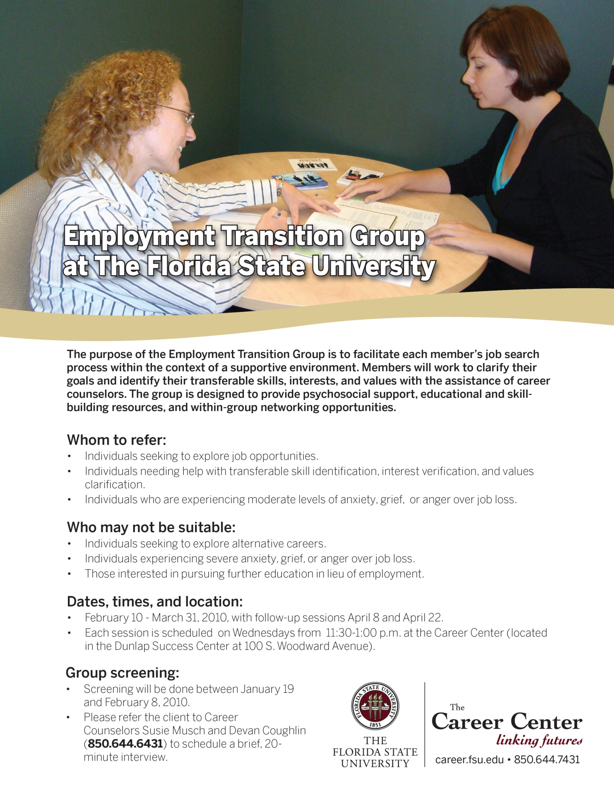
RECRUITMENT: EMPLOYMENT TRANSITION GROUP REFERRAL HANDOUT

APPENDIX C
RECRUITMENT: PROFESSIONAL JOB CLUB CARD

APPENDIX D
SCREENING: DATA SHEET

Florida State University Career Center: PROFESSIONAL JOB CLUB CLIENT INFORMATION
Name____________________________________ Age (optional) ___________________
Address__________________________________ E-mail ______ ___________________
City________________________________ State__________ Zip Code___________________
Home Phone__________________________ Alternative Phone_______________________________
Are you currently enrolled in school? (Circle.) Yes No
If yes, what is your current area of study? ___________________________________________________
Please circle the number or letters showing the highest year of formal schooling received:
High School: 10 11 12 College: 1 2 3 4 5 6 MA MS PhD Other
Major/Area of Study_____________________________________________________________________
Are you currently employed? (Circle.) Yes No Hours per week: __________________________
If yes, in what occupation? ________________________________________________________________
List the types of jobs you are pursuing in your job search.
_____________________________ _________________________________
_____________________________ _________________________________
_____________________________ _________________________________
What is your timeline for obtaining new employment? ________________________________________
Mark a rating number from 1 (Strongly Disagree) to 7 (Strongly Agree) that best responds to items 1-7.

- Decisions about my career tend to directly affect my health……………………………..…….. _________
- Decisions about my career create a great deal of tension………………………………………… _________
- I have felt fidgety or nervous as a result of having to make career decision………….….. _________
- If I did not worry about my career, my health would probably improve…………………... _________
- Problems associated with my career decisions have kept me awake at night………..…. _________
- I have felt nervous before attending classes that made me think about my career…… _________
- I often think about my career even when I am doing other things…………………………... ________
Presently, how confident do you feel in your ability to…
…independently carry out a successful job search? (Circle.)
Not confident at all 1 2 3 4 5 6 7 Highly confident
… write a quality resume? (Circle.)
Not confident at all 1 2 3 4 5 6 7 Highly confident
… write a quality cover letter? (Circle.)
Not confident at all 1 2 3 4 5 6 7 Highly confident
…answer interview questions? (Circle.)
Not confident at all 1 2 3 4 5 6 7 Highly confident
…network effectively? (Circle.)
Not confident at all 1 2 3 4 5 6 7 Highly confident
…identify resources that provide employment leads? (Circle.)
Not confident at all 1 2 3 4 5 6 7 Highly confident

Interview:
What do you hope to gain from participating in a job club?

Please detail up to now what you have currently done to prepare for your job search.

How do you feel about sharing your experiences in a group?

How do you typically handle a conflict or a disagreement of opinions with another person?

APPENDIX E
JOB CLUB AGENDAS 1-5
Professional Job Club – Agenda for Session #1

Goals and rationale of group (Susie)
  - Who knows anything about how a job club works?
  - Definition: Informal networking venue that permits job searchers to expand contacts and serves as a support group
  - What are some of the emotions you personally associate with the job search process?
  - Goals of this particular group (elaborate):
    - To help expand contacts and resources
    - To learn more about strategies for job searching
    - To improve your use of existing resources and strategies
      - Co-facilitators will add to these things by discussing practical, educational resources
    - Hold one another accountable
      - All within supportive environment
General format
    - 1 hour and 30 minutes, weekly meetings
    - Beginning: Share results and achievements of previous week’s job hunting
    - Middle: Ask for support in specific areas (e.g., dressing, interview skills, cover letter writing, etc.)
      - Then, co-facilitators will discuss topic of choice identified during previous week
    - End: Set a goal to be achieved by next meeting (e.g., add ten contacts to network list, do two mock interviews, research three new employers, etc.)
Introductions (Devan)
  - To get to know one another a little better, each take a few minutes to share:
  - First name
  - What brings you to this group
  - Job targets you are considering
  - What was a career fantasy you had as a child?
  - Next person will begin by reminding us of the name of last person who spoke
  - Co-facilitators can demonstrate process by going first
Ground rules (Susie)
  - Good to start by establishing some expectations for our interactions together
  - Everyone take a moment to write down one ground rule you appreciate when others respect in conversations and interactions with you
  - Co-facilitators can share ground rules (that people attend, participate, and do homework)
  - Go around and share ground rules, linking where appropriate
  - Confidentiality doesn’t apply as much as in other groups, because point is networking
    - Do inform when you are discussing something you would not like repeated

Assessment of current resources and strategies (Devan)
  - Get an idea of where we’re starting
  - Take a moment to reflect upon and write down you been doing and using as part of your job search thus far and how well that has been working
  - Write down any feedback or suggestions you have for someone
  - Go around and share current resources and strategies
  - At end, ask people to share any feedback they jotted down
Focus of future educational resources (Susie)
  - Asked people to complete data sheet; one group of questions asked about comfort with various items
  - Sense is that most people want to learn about (in this order):
    - Resources for identifying leads
    - Interviewing/networking/cover letter
    - Resume writing
  - What are your thoughts on which of these you would like to learn more about next week?
ILP development (Devan)
  - Big part of job clubs are holding one another accountable for job search activities each week
  - May have some activities you were planning to do anyway; may have learned some today that you would like to implement
  - Introduce concept of ILP and pass out copies
  - Each write down one or two job-search related activities (can provide examples) that you plan on doing before next meeting
  - Again, as each person shares, jot down any feedback about what he or she may want to add
  - Go around group and share ILP items
  - Allow a few minutes for feedback from other members about items to add

Professional Job Club – Agenda for Session #2

- Allow new people to introduce themselves (name, childhood career fantasy, what brings them to group, and job targets) and people who were here last week to briefly reiterate their names and what brings them to group. (Devan)
- Introduce session start process again – what job search-related activities did each person engage in last week, and how did those go? Go around and share. (Susie)
  - Explain that from now on, we will be documenting these activities more purposefully, using ILPs; demonstrate.
- Introduce session middle process again – what concerns related to the job search would people like to discuss this week and obtain feedback from the group about? (Devan)
- Explain why we decided to cover networking as first topic; most applicable to multiple components of job search. (Susie)
  - What are your experiences with and feelings toward networking? (Susie)
- Explain how to develop an elevator speech. (Devan)
  - Have each person spend a few minutes creating their own (jot down a few points to cover).
  - Have each person share theirs with the group/a partner, while the group/partner jots down feedback.
  - At end of each person’s speech, have group/partner provide feedback.
- Introduce session end process again – what activities related to job search is each person going to focus upon for next week? (Devan)
  - Jot these down on the ILP.
  - Take turns sharing with group, if time.

Professional Job Club – Agenda for Session #3

- Allow new people to introduce themselves (Devan)
- Last week’s job search-related activities
  - How did those go?
  - Go around and share. (Susie)
- Concerns related to the job search (Devan)
- Explain why we decided to cover employer resources as next topic; logical next step, expressed interest
  - How can you use the elevator speech developed last week? (Susie)
- Show and tell of career center resources. (Devan)
  - Professional organizations and resources one can use to identify these. (Susie)
  - Volunteering and related resources. (Devan)
  - Information interviews. (Susie)
  - How would you use these resources in your job search?
  - Participants identify one resource to use on their ILPs for next week
- What activities related to job search is each person going to focus upon for next week? (Devan)
  - Jot these down on the ILP.
  - Take turns sharing with group, if time.

Professional Job Club – Agenda for Session #4

- Allow new people to introduce themselves (name, childhood career fantasy, what brings them to group, and job targets) and people who were here last week to briefly reiterate their names and what brings them to group. (Devan)
- Last week’s job search-related activities
  - How did those go?
  - Go around and share. (Susie)
- Concerns related to the job search (Devan)
- Explain why we decided to cover Resumes as next topic; first step before tailoring to job target. (Susie)
  - Introduce idea of 30 second resume review? (Susie)
  - Participants will swap resumes with one another, review resume for 30 seconds, write down feedback on designated worksheet, provide feedback verbally to partner
  - Discussion of learning or key take-aways
  - Participants identify one resume related ILP activity
- What activities related to job search is each person going to focus upon for next week? (Devan)
  - Jot these down on the ILP.
  - Take turns sharing with group, if time.
  - Remind participants to bring job listing or use ONET.

Professional Job Club – Agenda for Session #5

- Allow new people to introduce themselves (name, childhood career fantasy, what brings them to group, and job targets) and people who were here last week to briefly reiterate their names and what brings them to group. (Devan)
- Last week’s job search-related activities
  - How did those go?
  - Go around and share. (Susie)
- Concerns related to the job search (Devan)
- Explain why we decided to cover Resumes /Interviews as next topic; resumes tailored to specific positions make for a stronger interview. (Susie)
  - Introduce idea of how employers identify potential candidates, use employer buzzwords (Susie)
  - Participants will first identify key buzzwords in a job announcement or ONET descriptions, and review their own resumes with keyword rubric (worksheet).
  - Participants will then share changes they wish to make with larger group.
- Solicit interview concerns and discuss
- Introduce STAR approach to behavioral interviewing
  - In dyads: participants take turns answering two behavioral interviewing questions.
  - Discuss key takeaways in larger group
- What activities related to job search is each person going to focus upon for next week? (Devan)
  - Jot these down on the ILP.
  - Take turns sharing with group, if time.

APPENDIX F
PROFESSIONAL JOB CLUB WORKSHEETS 1-5 (AND FEEDBACK FORMS)

Professional Job Club
Worksheet 1: Current Job Searching Strategies and Resources

Participant: _________________________________

Strategy: Here you might list methods, such as applying to posted jobs, emailing past co-workers, etc.

Resources: Here you might list items, such as Company websites, Tallahassee Democrat, etc.

Professional Job Club
Worksheet 2: Elevator Speech Worksheet

Participant: ________________________________________
- Who am I? (introduce yourself)

- What field or industry am I in?

- What position am I in? In what capacity do I serve?

- What is my USP (Unique Selling Proposition)? What makes me different from the competition?

- What benefits do my customers derive from my services? -- What benefits can employers derive from skills, based on my proven accomplishments?

Check up: Does your elevator speech speak to any of the following?

- Pain -- Paint a graphic picture of the "pain" or problems that the employer is experiencing.
- Credibility -- Your qualifications for solving the problem.
- Solution -- Specifically hint at how you can provide a solution (but don't give away the farm before you have the job).
- Gain -- Explain the benefits the employer will experience.
- Impact -- illustrate the difference those benefits will make in the organization.
- Emotion -- Describe how the benefits will make the employer feel.
- Prove -- Provide evidence that support your claims through examples or stories.

* Adapted from Katharine Hansen’s Fantastic Formulas for Composing Elevator Speeches
Professional Job Club

Worksheet 3: Current Networking Resources and Strategies

Participant: _________________________________

Resources: Here you might list clubs or professional associations you would like to join, social networking sites, etc.

Strategies: Here you might list activities like attend one chamber meeting a month, conduct information interviews, etc.

Professional Job Club

Worksheet 4: Suggested Resources

  - Employer directories

Example:

How to use:

  - Professional associations:
Example:
How to use:

  - Social networking:
Example:
How to use:

  - Job boards:
Example:
How to use:

  - Other sources of employment listings:
Example:
How to use:

  - Hidden job market:
Example:
How to use:

Professional Job Club
Worksheet 5: Buzzwords for Tailoring Resumes

Buzzwords are used by employers to identify potential candidates the same way that you or I would use Google to find a restaurant review or a book sale. Make sure that you are using key buzzwords for your industry or career field and when possible are using the employer’s unique language.

Example: Assistant to the Dean of Students –
Act as a liaison between students and services offered by the department

Buzzword: Act as liaison

Synonyms: Collaborated, Partnered, Coordinated

Keyword Rubric:

Buzzwords found in job description or ONET | Times Used in my Resume | Synonyms to Change

Professional Job Club
Worksheet 6: Interview Preparation

Participant: ________________________________________

The STAR approach can be helpful in answering interview questions.

STAR stands for …

SITUATION: Describe the situation; provide as much detail as possible
TASK: Describe the task you set forth to accomplish
ACTION: Describe the action you took to accomplish the task
RESULT: Describe the result of the situation; to what extent was the outcome related to your unique contribution.

1. Worked effectively under pressure. | 14. Were disappointed in your behavior.
2. Handled a difficult situation with a co-worker. | 15. Had to deal with an irate customer.
3. Were creative in solving a problem. | 16. Delegated a project effectively.
4. Missed an obvious solution to a problem. | 17. Surmounted a major obstacle.
5. Were unable to complete a project on time. | 18. Set your sights too high (or too low).
6. Persuaded team members to do things your way. | 19. Prioritized the elements of a complicated project.
7. Wrote a report that was well-received. | 20. Got bogged down in the details of a project.
8. Anticipated potential problems and developed preventive measures. | 21. Lost (or won) an important contract.
9. Had to make an important decision with limited facts. | 22. Made a bad decision.
10. Were forced to make an unpopular decision. | 23. Had to fire a friend.
11. Had to adapt to a difficult situation. | 24. Hired (or fired) the wrong person.
12. Were tolerant of an opinion that was different from yours. | 25. Turned down a good job.

*Adapted from MRI Champions, Behavioral Interviewing, n.d.
Professional Job Club

Participant Feedback Form

Topic: _______________________________________

Participant: _______________________________________

Participant Feedback

Topic: ________________________________________

Participant: ________________________________________

REFERENCES
Borgen, W. A. (1999). Implementing “starting points”: A follow-up study. Journal of Employment Counseling, (36), 98-114.
Guindon, M. H., & Smith, B. (2002). Emotional barriers to successful reemployment: Implications for counselors. Journal of Employment Counseling, (39), 73-82.
Moorhouse, A., & Caltabiano, M. L. (2007). Resilience and unemployment: Exploring risk and protective influences for the outcome variables of depression and assertive job searching. Journal of Employment Counseling, 44, 115-124
Sampson, J.P., Reardon, R. C., Peterson, G. W., & Lenz, J. G. (2004). Career counseling & services: A cognitive information processing approach. Belmont: Brooks Cole.
Sampson, J. P., Jr., Peterson, G. W., Lenz, J. G., Reardon, R. C., & Saunders, D. E. (1996). Career Thoughts Inventory. Odessa, FL: Psychological Assessment Resources, Inc.
Waters, L. E. & Moore, K. A. (2002). Predicting self-esteem during unemployment: The effect of gender, financial deprivation, alternate roles, and social support. Journal of Employment Counseling, (39), 171-189.

