Cultivating Positivity in Career Counselors-In-Training:
A Group Processing Intervention

Survey Highlights
Respondents (N=16) Breakdown:
MS/Ed.S Career Counseling 1st year students – 6 Ph.D School Counseling/Counseling Psych 1st year students – 2
MS/Ed.S Career Counseling 2nd year students – 5 Ph.D School Counseling/Counseling Psych 2nd year+ students – 3

- 15 of the 16 trainees surveyed felt that group processing meetings helped them feel more confident in career advising ability across multiple topics including: resume/cover letter critiques, personal statement critiques, job search strategies, interview preparation, career fair preparation, and choosing a major/occupation.

- Second year career counseling master’s students felt that group processing meetings increased their desire to pursue a career advising/counseling occupation in both survey administrations with the second survey returning an increased magnitude of endorsement. First year students in the same cohort, on the other hand, felt that meetings increased their desire to pursue a career advising/counseling occupation in the first survey, but not in the second.

- The majority of trainees felt that that group processing meetings made them feel a stronger identification with the career advising/counseling profession at both survey collections. All but 1 trainee agreed or strongly agreed with this item at the first survey collection. At the second survey collection, 1 trainee strongly disagreed (the same trainee that disagreed with this item in the first survey), around 25% of trainees (4 students) felt neutrally, and nearly 75% of students either agreed or strongly agreed that group meetings increased their feeling of identification with the career counseling/advising profession.

- The majority of trainees felt that group processing meetings made them feel 1) more engaged in the career advising/counseling field and 2) more motivated seek further information about trends and current events in the career advising/counseling field at both survey events, however, there was some migration of responses toward the middle at the second survey administration.

What trainees felt was helpful… What trainees want more of…
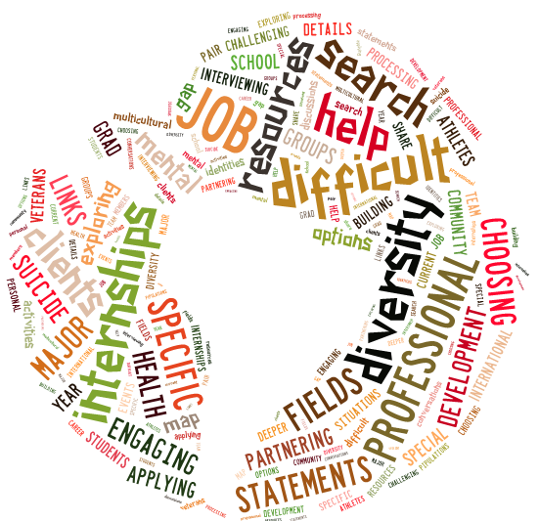

Sample Group Processing Meeting Agenda

- Employer Relations Spotlight
- Experiential Learning Spotlight
- Resource Corner
- Activity: Diversity scenarios/processing
- Announcements
  - Handshake Check-in
  - Suggestion box submissions
  - New Desk Schedule starts 6/26
- Donut Award

Sample Processing Prompts/Case Studies

- Explain your process for assessing and conceptualizing a client on desk? (How do you decide what their problem is and how to help them?)

- Share the story of the hardest desk client you ever had and why they were the hardest (how did you handle it?)

- Aziz is a 21-year-old Afghani male who is a junior at FSU majoring in engineering. He drops in for a resume critique. You notice that Aziz’s resume is not very robust, so you ask him if there are any other skills/experiences he might add to the document to make it stronger. He tells you he is president of the Muslim Student Association, but he took this off his resume in light of the current political attitude in the US toward immigrants, and Muslims in particular. He asks if you think he should add it back.
  - What are your fears/concerns about working with Aziz?
  - Have you ever had a client like this? Please share and explain what you did.
  - What verbal interventions might you use with Aziz in this situation? How would you word your responses?
  - What strategies/resources might you use to help this individual?

Group Processing Meeting Tips and Suggested Strategies for Implementation

- Make sure participants understand the purpose and boundaries of meetings

- Be mindful of who is in the room (e.g. developmental levels, job functions, organizational statuses, etc.)

- Be intentional when planning meeting agendas

- Solicit participant suggestions for meeting topics

- Consider incorporating professional development topics in addition to skill-building activities

- Alternate lecture/presentations with activities and open processing time

- Vary small group composition each meeting to give participants exposure to multiple, diverse perspectives

- Invite partners from within your department and outside career services to give presentations to the group

